Simple Linear Regression:
1. Finding the equation of the line of best fit

Objectives: To find the equation of the least squares regression line of y on x.

Background and general principle
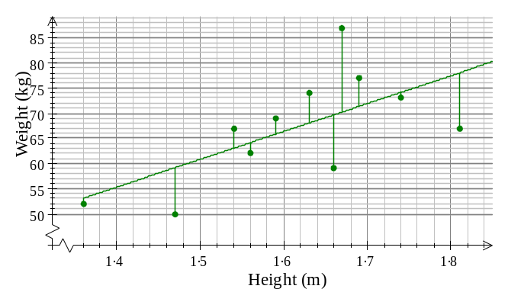
The aim of regression is to find the linear relationship between two variables. This is in turn translated into a mathematical problem of finding the equation of the line that is closest to all points observed.
Consider the scatter plot on the right. One possible line of best fit has been drawn on the diagram. Some of the points lie above the line and some lie below it.
The vertical distance each point is above or below the line has been added to the diagram. These distances are called deviations or errors – they are symbolised as 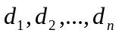.
ε₁
When drawing in a regression line, the aim is to make the line fit the points as closely as possible. We do this by making the total of the squares of the deviations as small as possible, i.e. we minimise 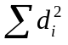.
If a line of best fit is found using this principle, it is called the least-squares regression line.

Example 1:
A patient is given a drip feed containing a particular chemical and its concentration in his blood is measured, in suitable units, at one hour intervals. The doctors believe that a linear relationship will exist between the variables.

Time, x (hours) | 0 | 1 | 2 | 3 | 4 | 5 | 6
Concentration, y | 2.4 | 4.3 | 5.0 | 6.9 | 9.1 | 11.4 | 13.5
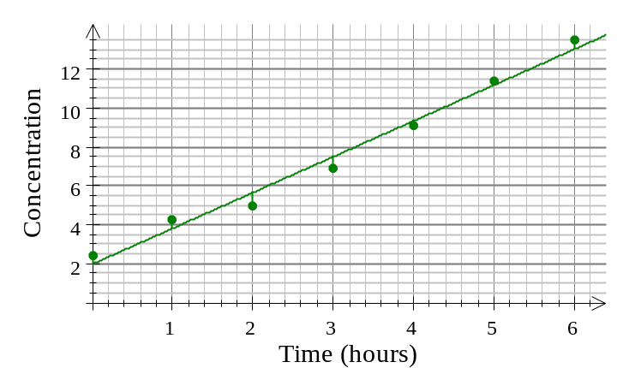
We can plot these data on a scatter graph – time would be plotted on the horizontal axis (as it is the independent variable). Time is here referred to as a controlled variable, since the experimenter fixed the value of this variable in advance (measurements were taken every hour).
Concentration is the dependent variable as the concentration in the blood is likely to vary according to time.
The doctor may wish to estimate the concentration of the chemical in the blood after 3.5 hours.
She could do this by finding the equation of the line of best fit.

There is a formula which gives the equation of the line of best fit.

** The statistical equation of the simple linear regression line, when only the response variable Y is random, is: 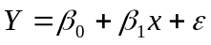 (or in terms of each point: 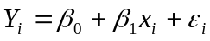)
Here 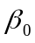 is called the intercept, 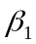the regression slope, is the random error with mean 0, is the regressor (independent variable), and the response variable (dependent variable).

** The least squares regression line is obtained by finding the values of andvalues (denoted in the solutions as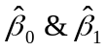) that will minimize the sum of the squared vertical distances from all points to the line:
The solutions are found by solving the equations: 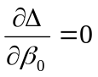 and 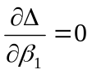

** The equation of the fitted least squares regression line is 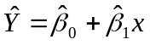 (or in terms of each point: 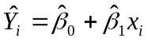) ----- For simplicity of notations, many books denote the fitted regression equation as: 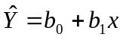 (* you can see that for some examples, we will use this simpler notation.)
where 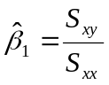 and 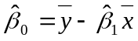.
Notations: 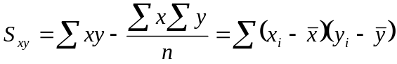; 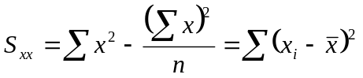;
and are the mean values of x and y respectively.

Note 1: Please notice that in finding the least squares regression line, we do not need to assume any distribution for the random errors 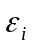. However, for statistical inference on the model parameters ( and), it is assumed in our class that the errors have the following three properties:
▪ Normally distributed errors
▪ Homoscedasticity (constant error variance 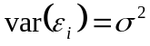for Y at all levels of X)
▪ Independent errors (usually checked when data collected over time or space)
***The above three properties can be summarized as: 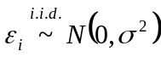, 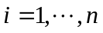

Note 2: Please notice that the least squares regression is only suitable when the random errors exist in the dependent variable Y only. If the regression X is also random – it is then referred to as the Errors in Variable (EIV) regression. One can find a good summary of the EIV regression in section 12.2 of the book: “Statistical Inference” (2nd edition) by George Casella and Roger Berger.

We can work out the equation for our example as follows:

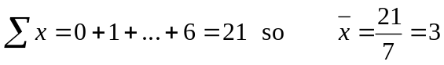
These could all be found on a calculator (if you enter the data into a calculator).
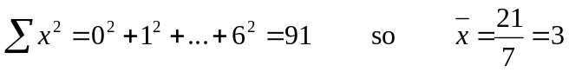

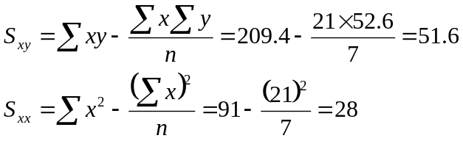

So, 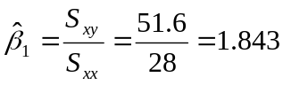 and 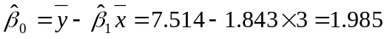.
So the equation of the regression line is = 1.985 + 1.843x.

To work out the concentration after 3.5 hours: = 1.985 + 1.843 × 3.5 = 8.44 (3sf)

If you want to find how long it would be before the concentration reaches 8 units, we substitute = 8 into the regression equation:
8 = 1.985 + 1.843x
Solving this we get: x = 3.26 hours

Note: It would not be sensible to predict the concentration after 8 hours from this equation – we don’t know whether the relationship will continue to be linear. The process of trying to predict a value from outside the range of your data is called extrapolation.

Example 2:
The heights and weights of a sample of 11 students are:

Height (m) h | 1.36 | 1.47 | 1.54 | 1.56 | 1.59 | 1.63 | 1.66 | 1.67 | 1.69 | 1.74 | 1.81
Weight (kg) w | 52 | 50 | 67 | 62 | 69 | 74 | 59 | 87 | 77 | 73 | 67

[]

a) Calculate the regression line of w on h.
b) Use the regression line to estimate the weight of someone whose height is 1.6m.

Note: Both height and weight are referred to as random variables – their values could not have been predicted before the data were collected. If the sampling were repeated again, different values would be obtained for the heights and weights.

Solution:
a) We begin by finding the mean of each variable:
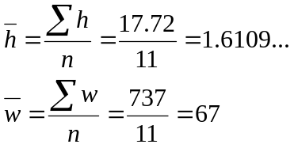
Next we find the sums of squares:
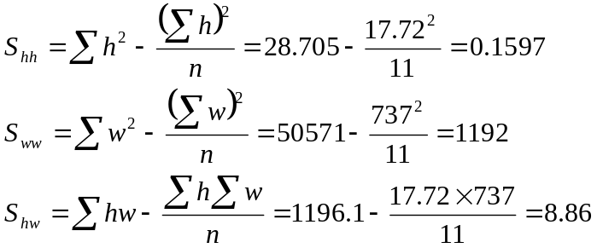
The equation of the least squares regression line is:
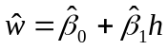
where
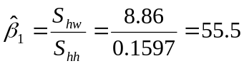
and
So the equation of the regression line of w on h is:
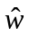 = -22.4 + 55.5h

b) To find the weight for someone that is 1.6m high:
= -22.4 + 55.5×1.6 = 66.4 kg

Simple Linear Regression:
2. Measures of Variation

Objectives: measures of variation, the goodness-of-fit measure, and the correlation coefficient

Sums of Squares

- Total sum of squares = Regression sum of squares + Error sum of squares
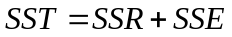
(Total variation = Explained variation + Unexplained variation)
- Total sum of squares (Total Variation): 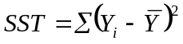
- Regression sum of squares (Explained Variation by the Regression): 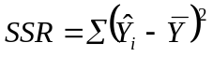
- Error sum of squares (Unexplained Variation): 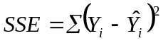
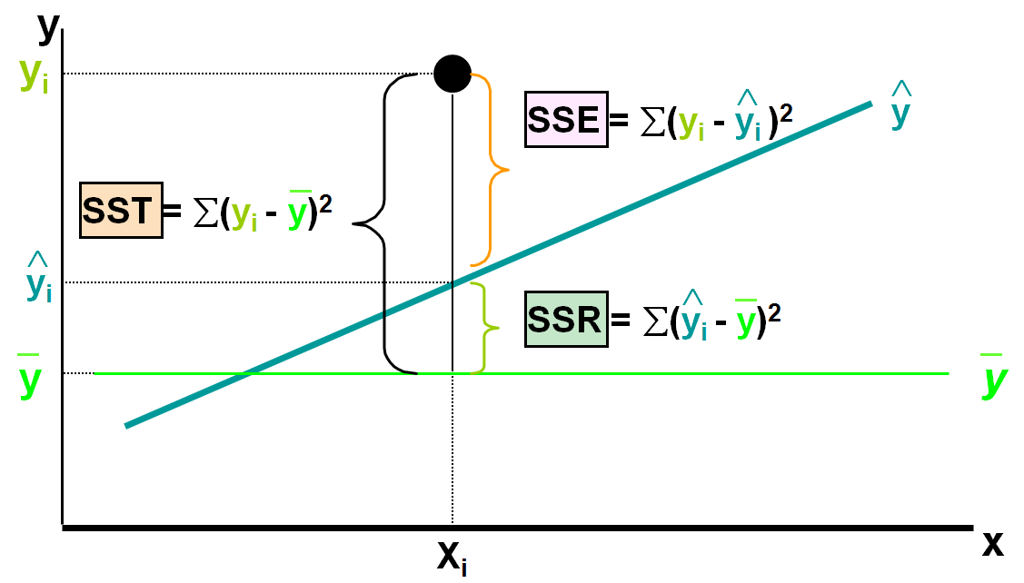

Coefficients of Determination and Correlation

Coefficient of Determination – it is a measure of the regression goodness-of-fit

It also represents the proportion of variation in Y “explained” by the regression on X
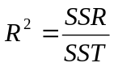; 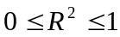

Pearson (Product-Moment) Correlation Coefficient -- measure of the direction and strength of the linear association between Y and X

- The sample correlation is denoted by r and is closely related to the coefficient of determination as follows:
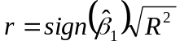; 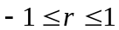

The sample correlation is indeed defined by the following formula:

- The corresponding population correlation between Y and X is denoted by ρ and defined by:

- Therefore one can see that in the population correlation definition, both X and Y are assumed to be random. When the joint distribution of X and Y is bivariate normal, one can perform the following t-test to test whether the population correlation is zero:

- Hypotheses
H₀: ρ = 0 (no correlation)
H_{A}: ρ ≠ 0 (correlation exists)

- Test statistic

Note: One can show that this t-test is indeed the same t-test in testing the regression slope β₁ = 0 shown in the following section.

Note: The sample correlation is not an unbiased estimator of the population correlation. You can study this and other properties from the wiki site:
http://en.wikipedia.org/wiki/Pearson_product-moment_correlation_coefficient

Example 3: The following example tabulates the relations between trunk diameter and tree height.

Tree Height | Trunk Diameter
y | x | xy | y² | x²
35 | 8 | 280 | 1225 | 64
49 | 9 | 441 | 2401 | 81
27 | 7 | 189 | 729 | 49
33 | 6 | 198 | 1089 | 36
60 | 13 | 780 | 3600 | 169
21 | 7 | 147 | 441 | 49
45 | 11 | 495 | 2025 | 121
51 | 12 | 612 | 2601 | 144
Σ=321 | Σ=73 | Σ=3142 | Σ=14111 | Σ=713

Scatter plot:
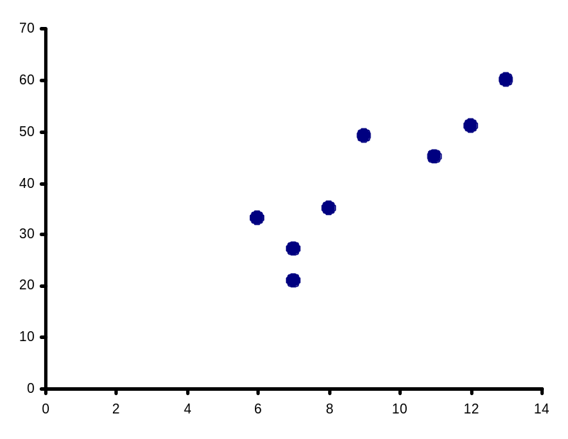

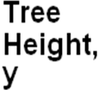

r = 0.886 → relatively strong positive linear association between x and y

Significance Test for Correlation
Is there evidence of a linear relationship between tree height and trunk diameter at the .05 level of significance?

H₀: ρ = 0 (No correlation)
H₁: ρ ≠ 0 (correlation exists)

At the significance level α = 0.05, we reject the null hypothesis because 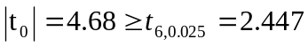 and conclude that there is a linear relationship between tree height and trunk diameter.

SAS for Correlation

Data tree;
Input height trunk;
Datalines;
35 8
49 9
27 7
33 6
60 13
21 7
45 11
51 12
;
Run;

Proc Corr data = tree;
Var height trunk;
Run;

Note: See the following website for more examples and interpretations of the output – plus how to draw the scatter plot (proc Gplot) in SAS: http://www.ats.ucla.edu/stat/sas/output/corr.htm

Standard Error of the Estimate (Residual Standard Deviation)

- The mean of the random error ε is equal to zero.
- An estimator of the standard deviation of the error ε is given by

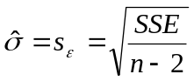

Simple Linear Regression:
3. Inferences Concerning the Slope

Objectives: measures of variation, the goodness-of-fit measure, and the correlation coefficient

t-test

Test used to determine whether the population based slope parameter (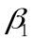) is equal to a pre-determined value (often, but not necessarily 0). Tests can be one-sided (pre-determined direction) or two-sided (either direction).

2-sided t-test:

  - H₀: β₁ = 0 (no linear relationship)
  - H₁: β₁ ≠0 (linear relationship does exist)

- Test statistic: 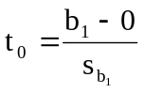
Where 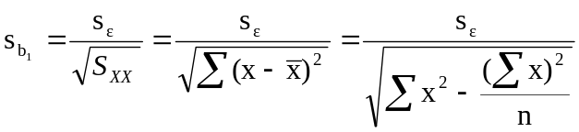
At the significance level α, we reject the null hypothesis if 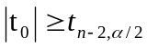
(Note: one can also conduct the one-sided tests if necessary.)

F-test (based on k independent variables)

A test based directly on sum of squares that tests the specific hypotheses of whether the slope parameter is 0 (2-sided). The book describes the general case of k predictor variables, for simple linear regression, k = 1.

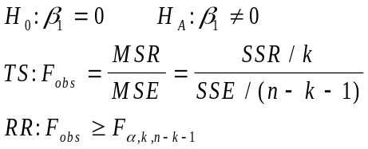

Analysis of Variance (based on k Predictor Variables – for simple linear regression, k = 1)

Source df Sum of Squares Mean Square F
Regression k SSR MSR=SSR/k F_{obs}=MSR/MSE
Error n-k-1 SSE MSE=SSE/(n-k-1) ---
Total n-1 SST --- ---

100(1-α)% Confidence Interval for the slope parameter, β₁:

- If entire interval is positive, conclude β₁>0 (Positive association)
- If interval contains 0, conclude (do not reject) β₁=0 (No association)
- If entire interval is negative, conclude β₁<0 (Negative association)

Example 4: A real estate agent wishes to examine the relationship between the selling price of a home and its size (measured in square feet). A random sample of 10 houses is selected
  - Dependent variable (y) = house price in $1000s
  - Independent variable (x) = square feet

House Price in $1000s (y) | Square Feet (x)
245 | 1400
312 | 1600
279 | 1700
308 | 1875
199 | 1100
219 | 1550
405 | 2350
324 | 2450
319 | 1425
255 | 1700

Solution: Regression analysis output:
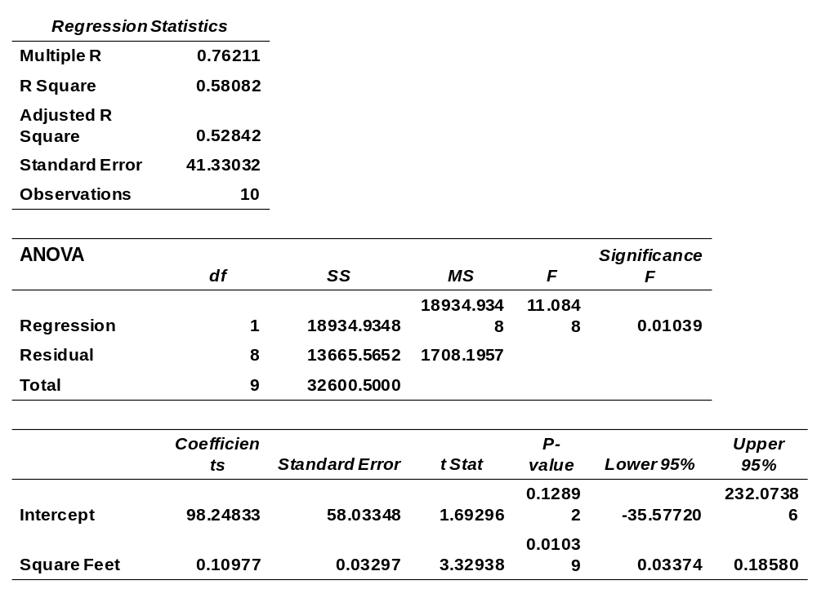



- b₁ measures the estimated change in the average value of Y as a result of a one-unit change in X
  - Here, b₁ = .10977 tells us that the average value of a house increases by .10977($1000) = $109.77, on average, for each additional one square foot of size

This means that 58.08% of the variation in house prices is explained by variation in square feet.

The standard error (estimated standard deviation of the random error) is also given in the output (above).

- t test for a population slope
  - Is there a linear relationship between x and y?
- Null and alternative hypotheses
  - H₀: β₁ = 0 (no linear relationship)
  - H₁: β₁ ≠ 0 (linear relationship does exist)
- Test statistic:

At the significance level α = 0.05, we reject the null hypothesis because 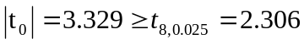 and conclude that there is sufficient evidence that square footage affects house price.
Confidence Interval Estimate of the Slope:

The 95% confidence interval for the slope is (0.0337, 0.1858)

Since the units of the house price variable is $1000s, we are 95% confident that the average impact on sales price is between $33.70 and $185.80 per square foot of house size

This 95% confidence interval does not include 0.
Conclusion: There is a significant relationship between house price and square feet at the .05 level of significance

Predict the price for a house with 2000 square feet:

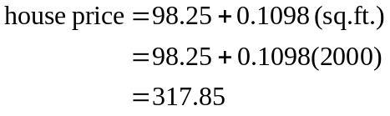

The predicted price for a house with 2000 square feet is 317.85($1,000s) = $317,85

Example 5 (SAS): What is the relationship between Mother’s Estriol level & Birthweight using the following data?
Estriol Birthweight
(mg/24h) (g/1000)
1 1
2 1
3 2
4 2
5 4

Data BW; /*Reading data in SAS*/
input estriol birthw@@;
datalines;
1 1 2 1 3 2 4 2 5 4
;
run;

PROC REG data=BW; /*Fitting linear regression models*/
model birthw=estriol;
run;

Finance Application: Market Model

- One of the most important applications of linear regression is the market model.
- It is assumed that rate of return on a stock (R) is linearly related to the rate of return on the overall market.
R = β₀ + β₁R_{m} +ε
R: Rate of return on a particular stock
R_{m}: Rate of return on some major stock index
β₁: The beta coefficient measures how sensitive the stock’s rate of return is to changes in the level of the overall market.

Example: Here we estimate the market model for Nortel, a stock traded in the Toronto Stock Exchange. Data consisted of monthly percentage return for Nortel and monthly percentage return for all the stocks.

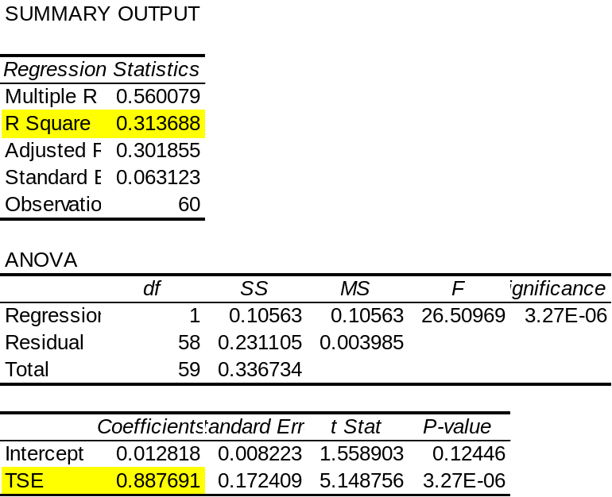

TSE (estimated regression slope): This is a measure of the stock’s market related risk. In this sample, for each 1% increase in the TSE return, the average increase in Nortel’s return is .8877%.

R Square (R²) This is a measure of the total risk embedded in the Nortel stock, that is market-related.
Specifically, 31.37% of the variation in Nortel’s return are explained by the variation in the TSE’s returns.

Linear Regression in Matrix Form

Data:
The multiple linear regression model in scalar form is

The above linear regression can also be represented in the vector/matrix form. Let

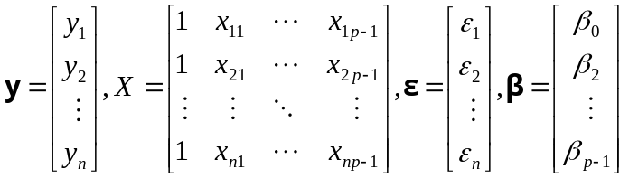.
Then,
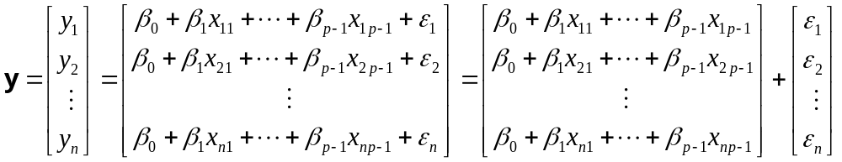 =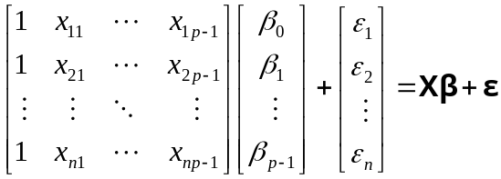.
Estimation:
Least square method:
The least square method is to find the estimate of minimizing the sum of square of residual,
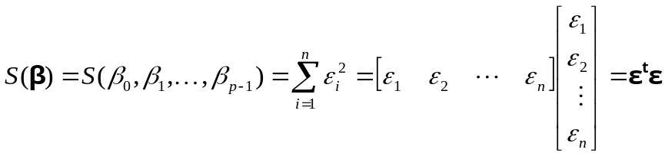
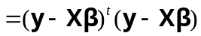
since 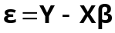. Expanding 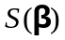 yields
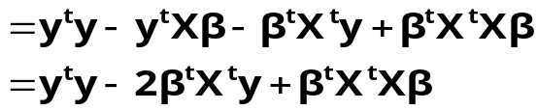
Note:
For two matrices A and B, 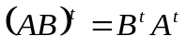 and 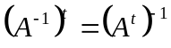

Similar to the procedure in finding the minimum of a function in calculus, the least square estimate b can be found by solving the equation based on the first derivative of ,
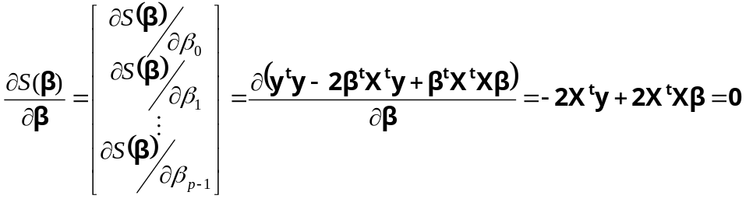

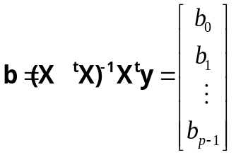
The fitted regression equation is
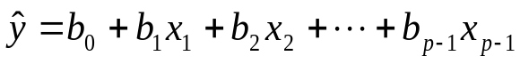.
The fitted values (in vector): 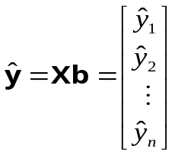
The residuals (in vector): 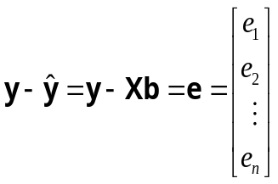
Note: (i) 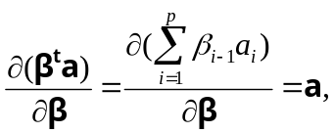 where 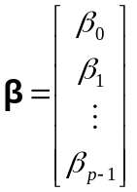 and 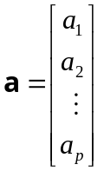.
(ii) 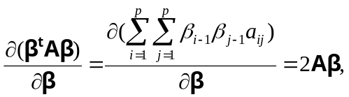 where  is any symmetric 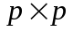 matrix.
Note: Since
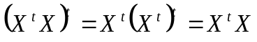,
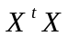 is a symmetric matrix.
Also,
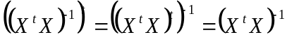,
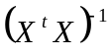 is a symmetric matrix.

Note: 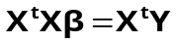 is called the normal equation.
Note:
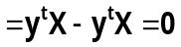.
Therefore, if there is intercept, then the first column of X is 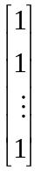. Then,
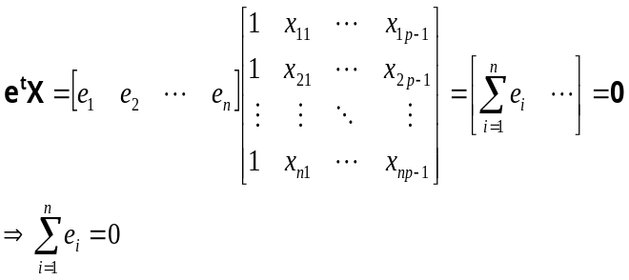
Note: for the linear regression model without the intercept, 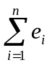 might not be equal to 0.

Properties of the least square estimate:
Two useful results:
Let 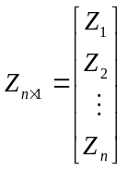 be a 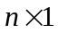 random vector, 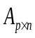 is a 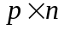 matrix and
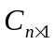 is a vector. Let
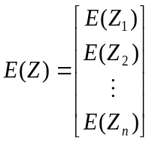
and
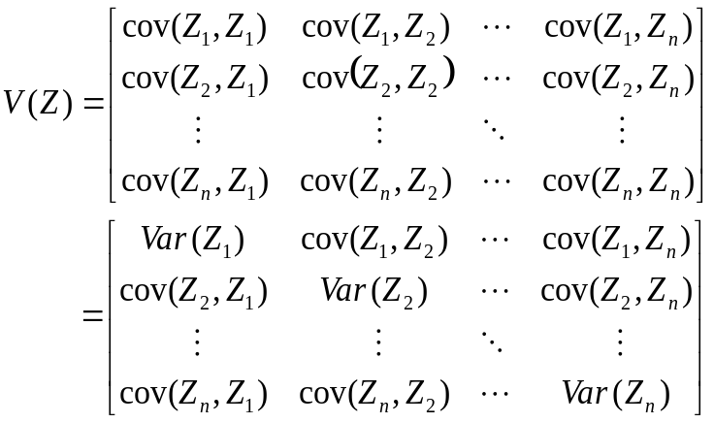.
Then
(a) .
(b) 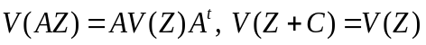
Note:
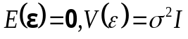

The properties of least square estimate:
1. 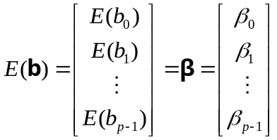
2. The variance –covariance matrix of the least square estimate b is
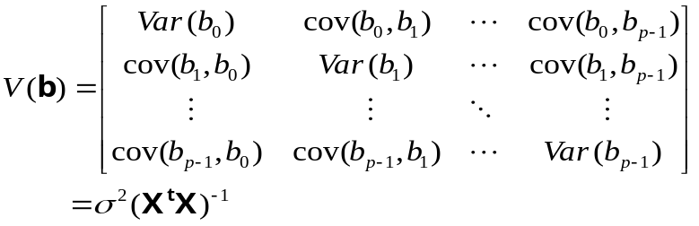
[Derivation:]
since
.
Also,
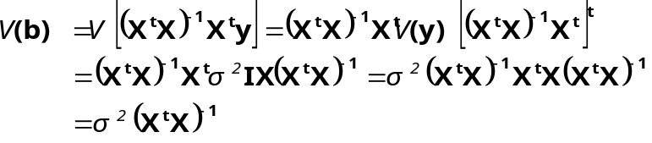
since
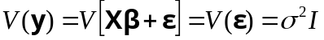
Example 6:
Heller Company manufactures lawn mowers and related lawn equipment. The managers believe the quantity of lawn mowers sold depends on the price of the mower and the price of a competitor’s mower. We have the following data:
Competitor’s Price 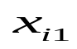 | Heller’s Price  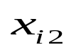 | Quantity sold  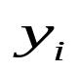
120 | 100 | 102
140 | 110 | 100
190 | 90 | 120
130 | 150 | 77
155 | 210 | 46
175 | 150 | 93
125 | 250 | 26
145 | 270 | 69
180 | 300 | 65
150 | 250 | 85
The regression model for the above data is
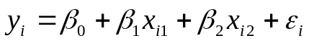.
The data in matrix form are
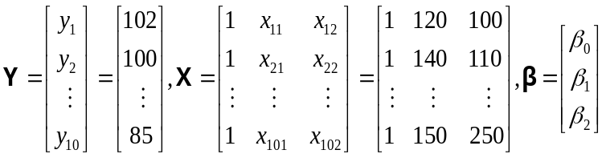.
The least square estimate is
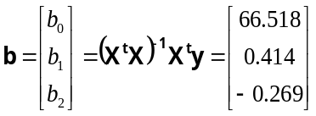.
The fitted regression equation is
.
The fitted equation implies an increase in the competitor’s price of 1 unit is associated with an increase of 0.414 unit in expected quantity sold and an increase in its own price of 1 unit is associated with a decrease of 0.269 unit in expected quantity sold.

Suppose now we want to predict the quantity sold in a city where Heller prices it mower at $160 and the competitor prices its mower at $170. The quantity sold predicted is

.

Example 7:
We show how to use the matrix approach to obtain the least square estimate and its expected value and the variance.
Let
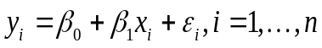.
Then,
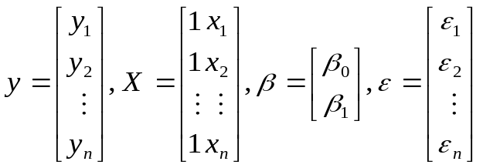
Thus,
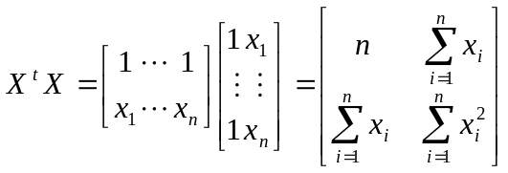 , 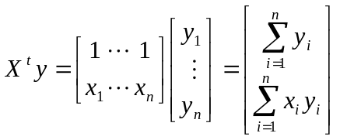
and
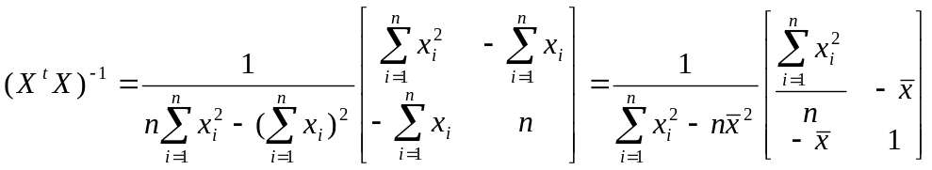
=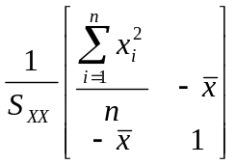,
since
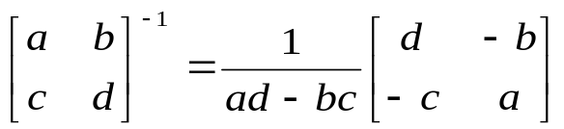
Therefore,
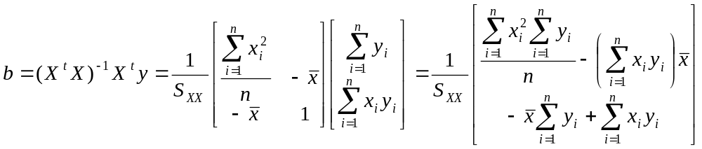
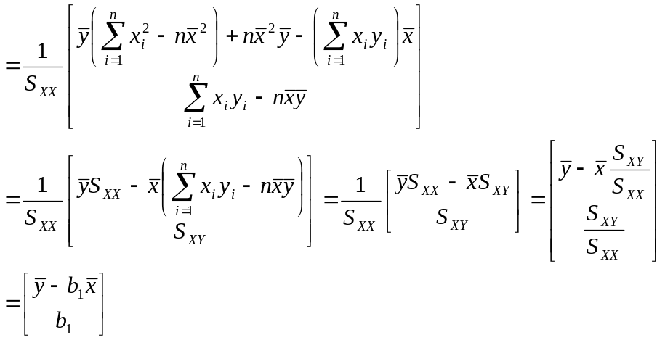
Also,
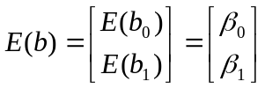
and
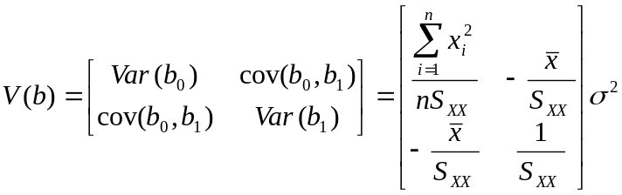

Acknowledgement: In compiling this lecture notes, we have revised some materials from the following websites:
www.schoolworkout.co.uk/documents/s1/Regression.doc
www.stat.ufl.edu/~winner/mar5621/mar5621.doc‎
www.fordham.edu/economics/Vinod/correl-regr.ppt‎
www2.thu.edu.tw/~wenwei/Courses/regression/ch6.1.doc
www.msu.edu/~fuw/teaching/Fu_Ch11_linear_regression.ppt‎
www.stanford.edu/class/msande247s/kchap17.ppt‎
Quiz. Due Tuesday at the beginning of the lecture
- Please prove that:
Total sum of squares = Regression sum of squares + Error sum of squares; that is,
- Please derive the method of moment estimators of the regression model parameters

http://users.stat.ufl.edu/~winner/sta4702.html MV

